Exercise: Introduction to Linux

1. Create a directory "exercise" inside your home directory and create nested(dir1/dir2/dir3) directory structure inside "excerise" with single command.

Answer: mkdir -p exercise/dir1/dir2/dir3

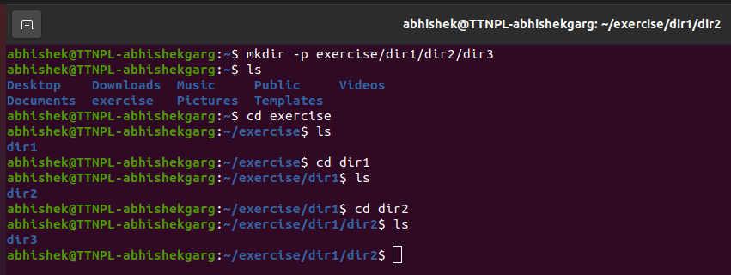

1. Create two empty files inside dir2 directory: emptyFile1,emptyFile2 in single command

Answer: touch emptyFile1 emptyFile2

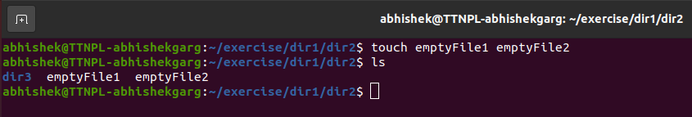

1. Create one file file1.txt containing text "hello world" and save it.

Answer: cat > file1.txt

Enter text “hello world” and press ctrl+D to save the file.

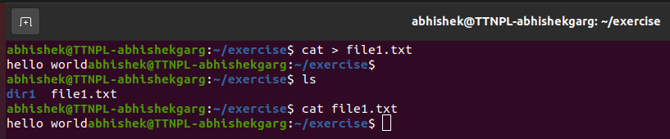

1. Find a "passwd" file using find command inside /etc. copy this files as passwd_copy and then rename this file as passwd_backup.

Answer: find /etc -name "passwd"

cp /etc/passwd passwd_copy

mv passwd_copy passwd_backup

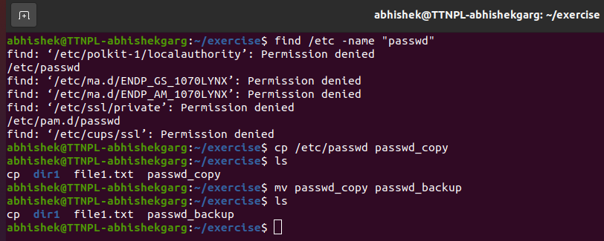

1. Try reading passwd_backup file in multiple tools: less,more,cat,strings etc and find the difference in their usage.

Answer: less passwd_backup

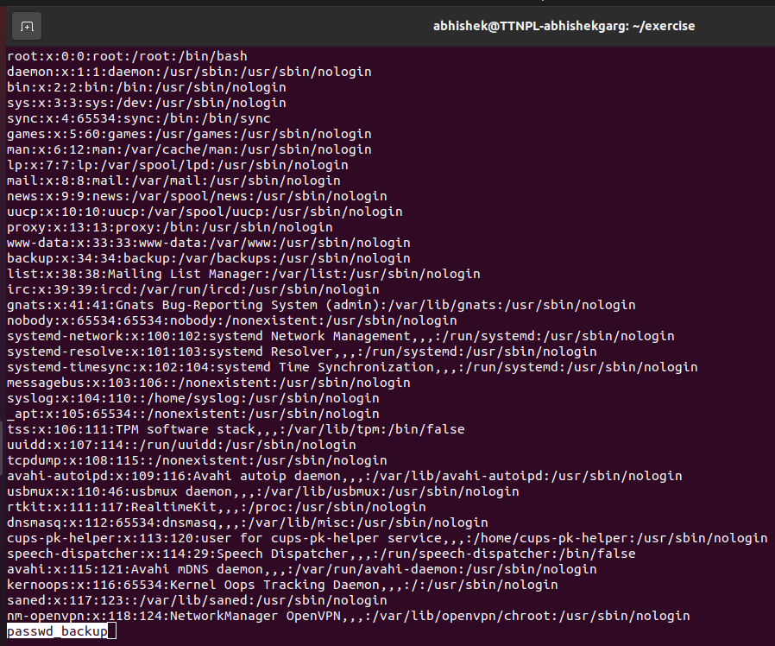

more passwd_backup

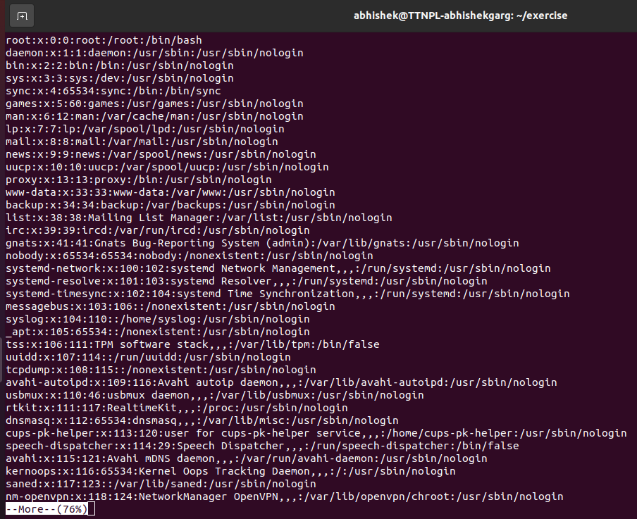

strings passwd_backup

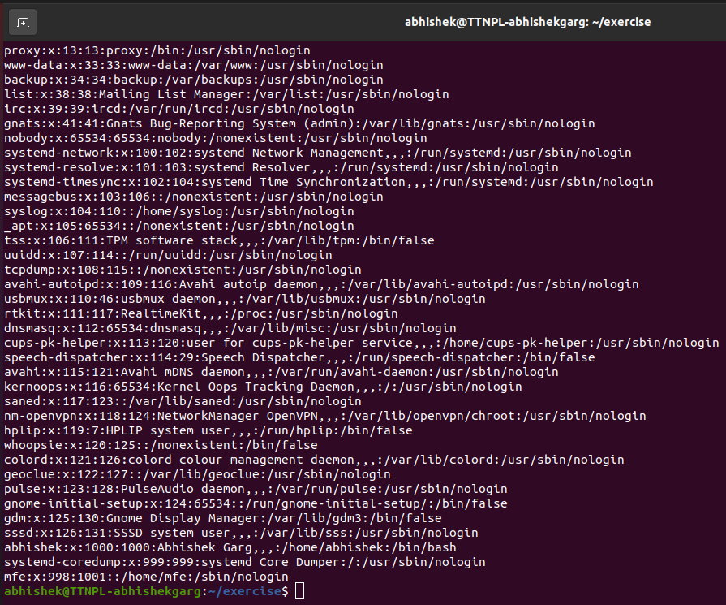

cat passwd_backup

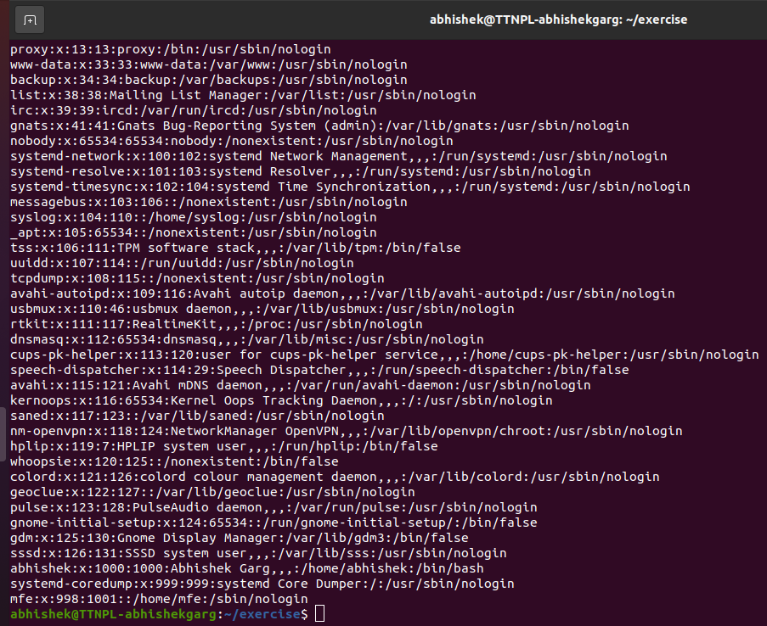

head passwd_backup

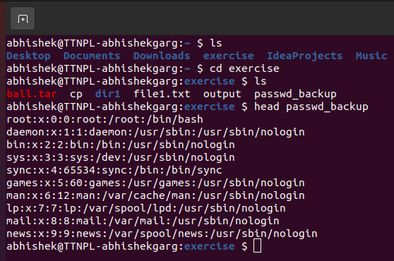

tail passwd_backup

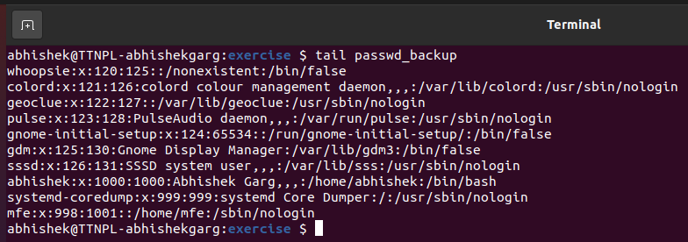

tac passwd_backu

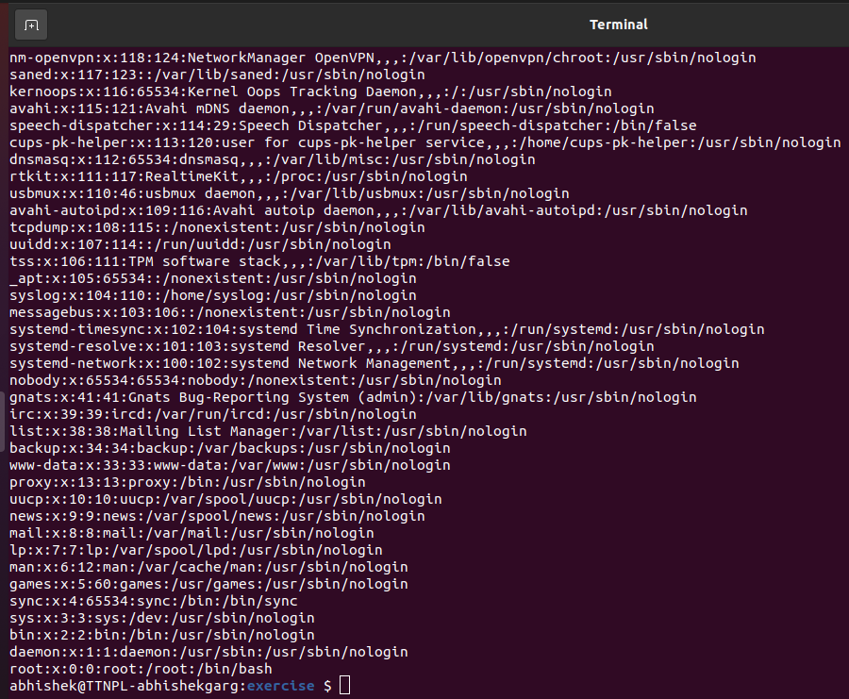

1. Find out the number of line in password_backup containing "/bin/false".

Answer: grep -c "/bin/false" passwd_backup

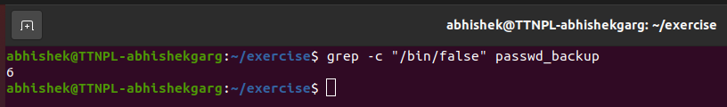

1. Get the first 5 lines of a file “password_backup” and Redirect the output of the above commands into file "output".

Answer: head -n 5 passwd_backup > output

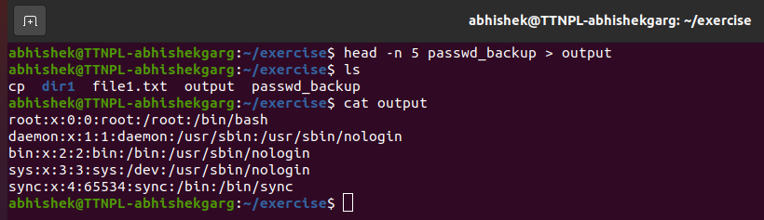

1. Create a "test" user,create its password and find out its uid and gid.

Answer: sudo useradd test

sudo passwd test

id -u test

id -g test

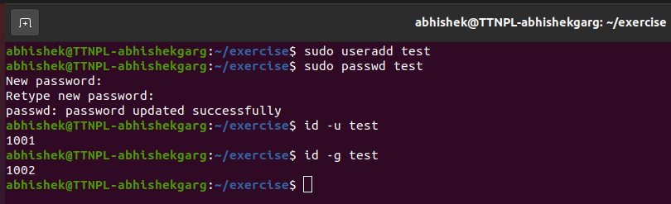

1. Change the timestamp of emptyFile1,emptyFile2 which are exist in dir2

Answer: touch emptyFile1 emptyFile2

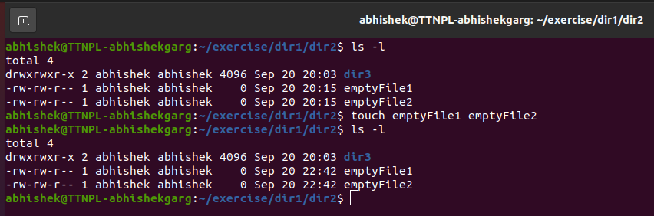

1. Login as test user and edit the "output" file created above. Since the permission wont allow you to save the changes. Configure such that test user can edit it.

Answer: su test

nano output

chmod 646 output

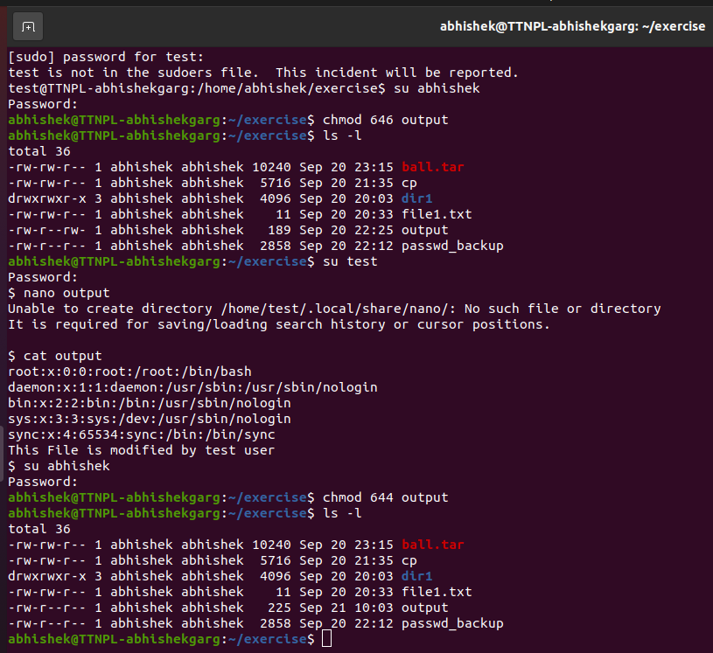

* 1. Add group owner of the "output" file as the secondary group of testuser and check/change the "output" file permission if it is editable by group. Once done revert the changes

Answer: chown test:test output

sudo chmod 664 output

sudo chmod 644 output

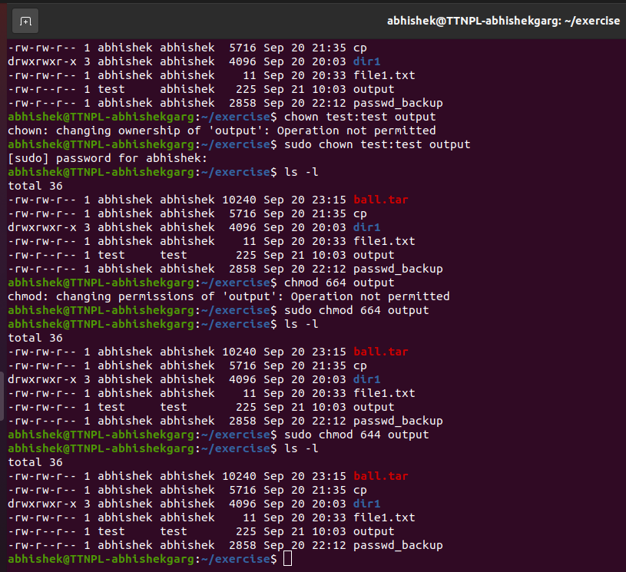

* 1. Make the file editable to the world so that test user can access it. Revert the changes after verification

Answer: chmod 646 output

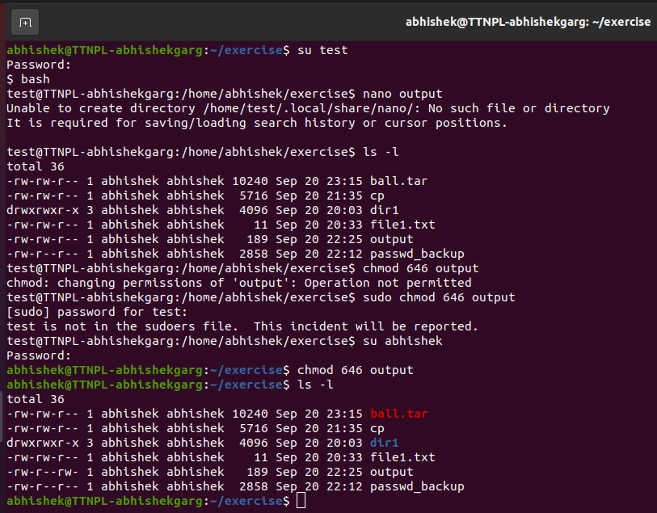

* 1. Change the ownership to edit the file.

Answer: sudo chown test:abhishek output

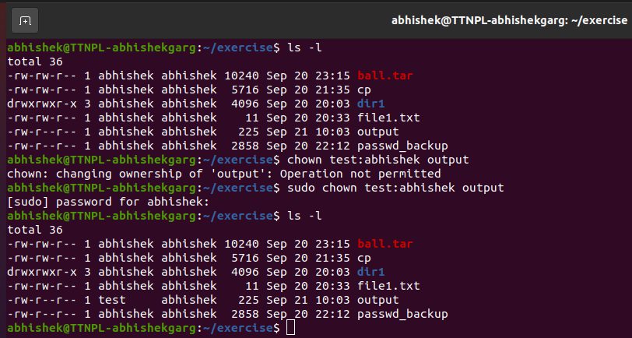

1. Create alias with your name so that it creates a file as "/tmp/aliastesting".

Answer: alias abhishek="touch /tmp/aliastesting"

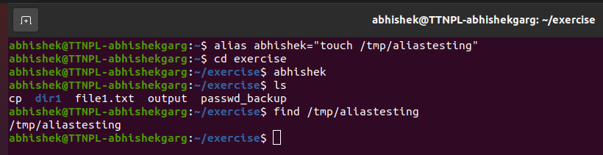

1. Edit ~/.bashrc file such that when you change to "test" user it should clear the screen and print "Welcome".

Answer:

1. Install “zip” package.

Answer: sudo apt-get install zip

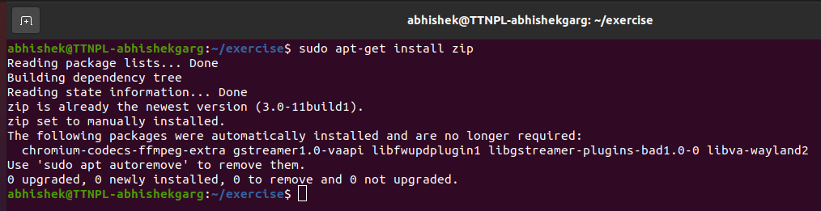

1. Compress "output" and "password_backup" files into a tar ball. List the files present inside the tar created.

Answer: tar -cvf ball.tar output passwd_backup

tar -tvf ball.tar

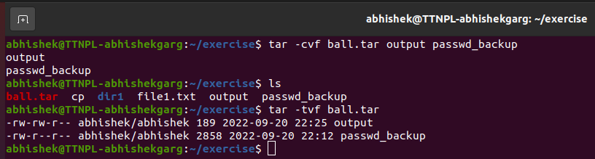

1. scp this file to test user

Answer:

1. Unzip this tar file by logging into the remote server

Answer:

1. Download any image from web and move to desktop

Answer: wget <https://static1.tothenew.com/blog/wp-content/themes/ttn/images/logo-large.png>

mv logo-large.png ~/Desktop

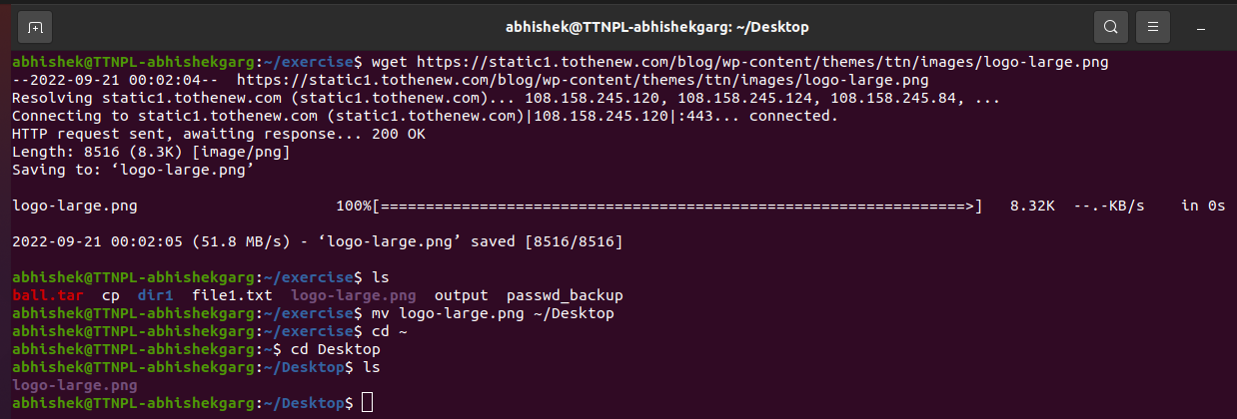

1. How to get help of commands usages.

Answer: cat --help

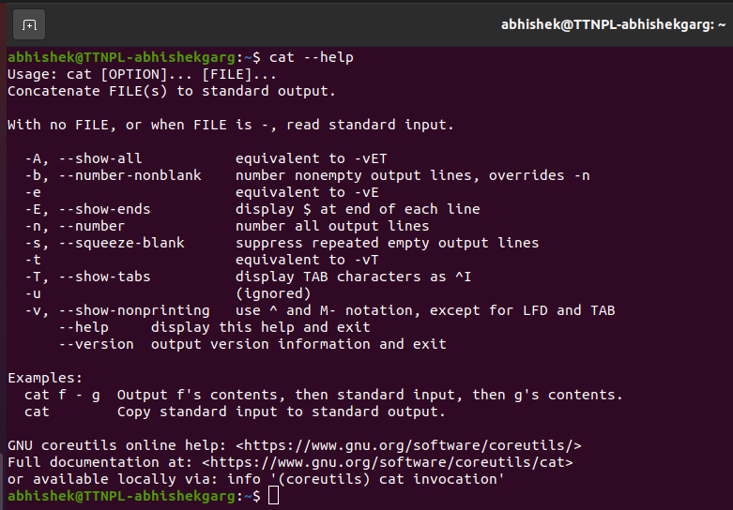

1. Create a symlink of /etc/services into /tmp/ports-info

Answer: ln -s /etc/services /tmp/ports-info

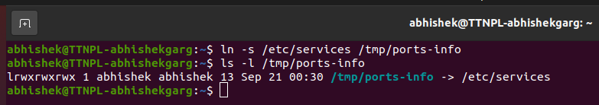

1. You are appointed as a Software/DevOps Engineer in ABC media services. On your first day you need to troubleshoot a problem. There is a command “xyz” somewhere installed in that linux system. But as a new joinee you do not have any idea about where is that Installed. How can you check that?

Answer: whereis xyz

